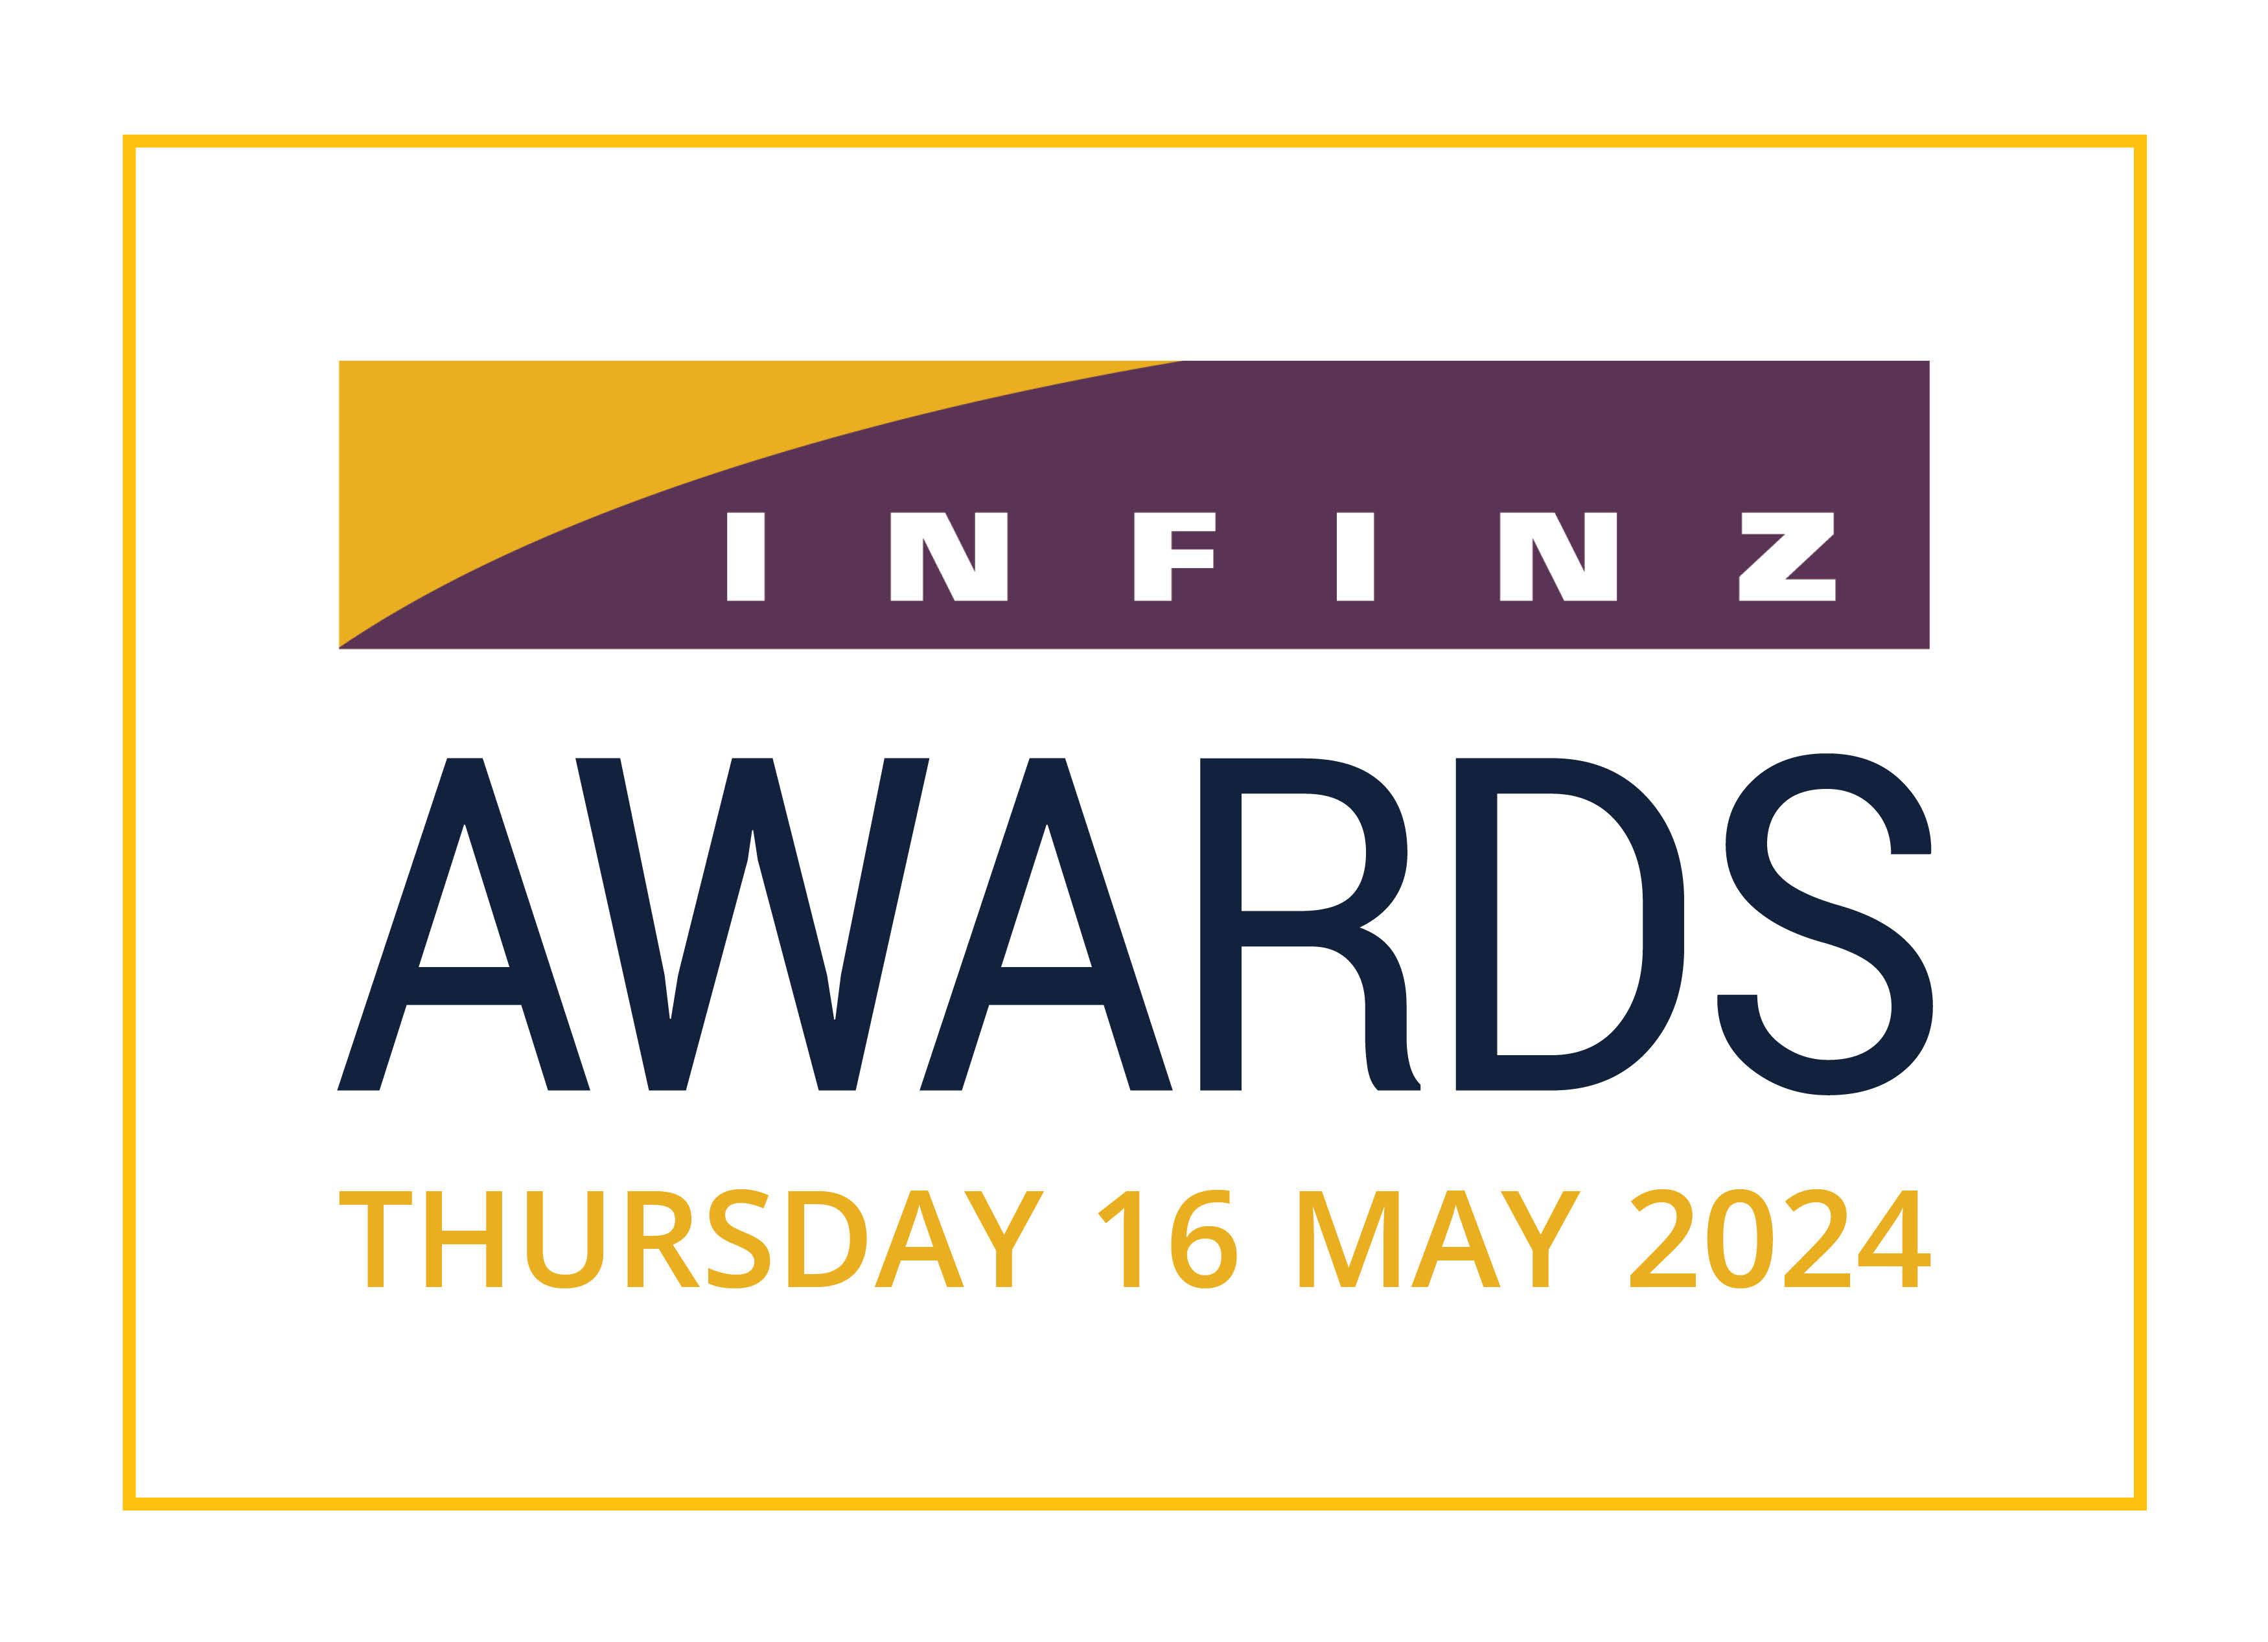

2024
NOMINATION FOR FELLOWSHIP
and/or DISTINGUISHED FELLOWSHIP

- Only Certified Members of INFINZ can nominate a member for either an INFINZ Fellowship or Distinguished Fellowship

- Each Nomination is to be kept confidential and the Nominee is not to be informed they are being nominated for a Fellowship

- The Board of INFINZ will be the sole arbiter in the conferring of Fellowships and is not required to give reasons why it has or has not conferred a Fellowship on any Nominee

- Nominations close 30 January 2024 and should be emailed to admin@infinz.com

To be eligible to become a Fellow of INFINZ the Nominee must be
- Member of INFINZ who has at least ten years relevant industry experience; and
- Who has been in a senior position or senior executive position for at least five years; and
- Who has made a significant and valuable contribution to the financial services ecosystem and wider society

Name of Nominee:
Name of Nominee:

Name and signature of Nominator/s

Nominator certification confirmation

________________________________________________________

To be filled in by INFINZ Office

It is the task of the nominator/s to provide sufficient information to the Membership Committee and Board of INFINZ so they can appropriately consider the merits of the nomination. For the professional business history and senior positions, nominator/s can provide a link to LinkedIn or a Business website where sufficiently comprehensive detail is available.

Professional and Business History

Senior Positions held by the Nominee (include name of organization, position held and dates)

Outline of Significant and Valuable Contribution to the financial services ecosystem and wider society

Supporting Statement from Nominator/s

